NAME: DUISENBAY BAUYRZHAN
PAIR: NONE
MACHINE: WINDOWS

4. We need to enter this command line to get all of the required CPU info, like model name, number of cores and logical processors:

Get-CimInstance Win32_Processor | Select-Object Name, NumberOfCores, NumberOfLogicalProcessors
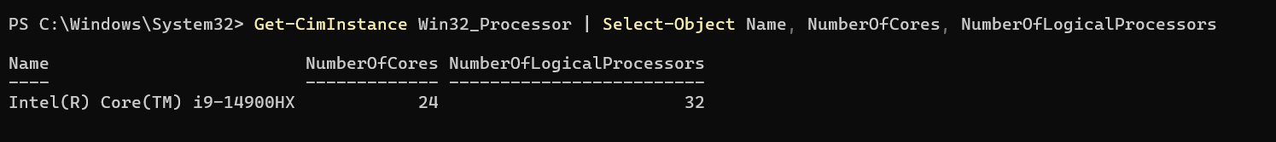
5. We need to enter this command line to get info about RAM:

Get-CimInstance Win32_PhysicalMemory | Select-Object @{Name="Capacity (GB)"; Expression={$_.Capacity / 1GB}}, Speed, DeviceLocator

6. Now we need to write a command line for getting the disk free space
Get-Volume | Format-Table DriveLetter, FileSystemLabel, @{Name="FreeSpace (GB)"; Expression={[math]::Round($_.SizeRemaining / 1GB, 2)}}, @{Name="TotalSize (GB)"; Expression={[math]::Round($_.Size / 1GB, 2)}} -AutoSize

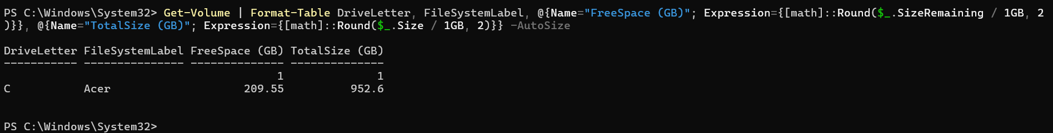
Now we need to write a command line for getting the disk model name, media type, bus type:
Get-Disk | Format-Table -Property FriendlyName, MediaType, BusType -AutoSize

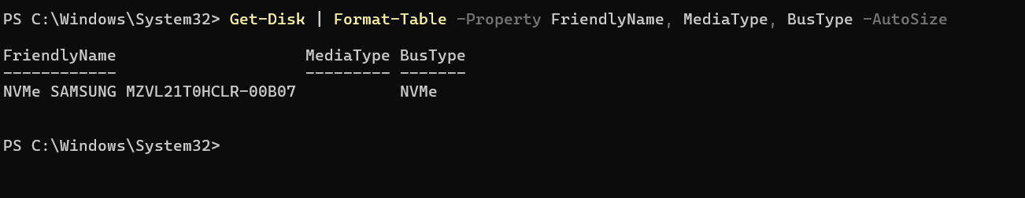

7.Need to use these commands to get specifications of BIOS:
Get-CimInstance -ClassName Win32_BIOS

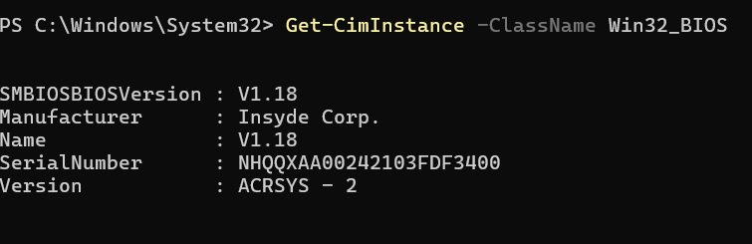
8.Need to use these commands to get the virtualization data, and as the security base on that is running then it’s present:
systeminfo | Select-String "Virtualization"

